Jason Santiago  
CET-2793C  
11-19-2024  
Dr. Roberts

Final Hands-On Project- Promote a Domain Controller Build

**Screenshots:**

* Server Manager, Local Server information (showing the server being promoted to a DC)

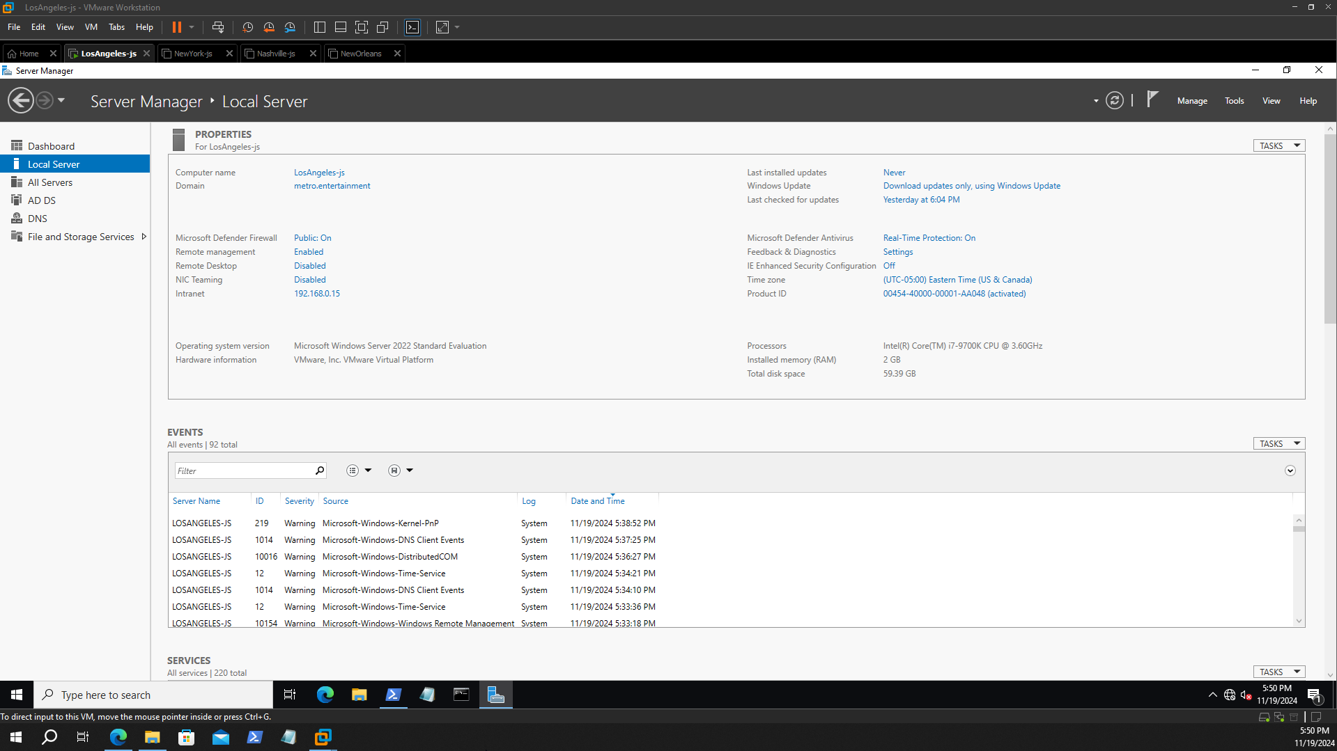

* Three OUs

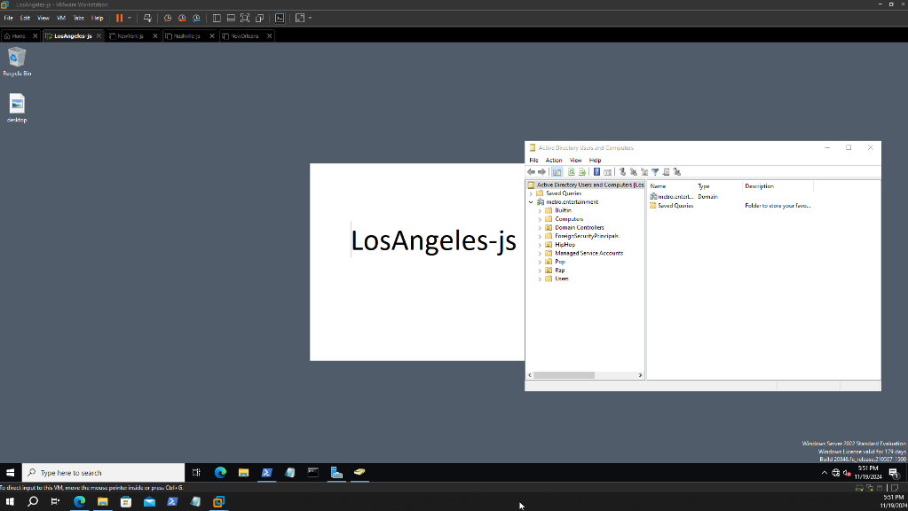

* Three Groups - in their OUs  
  HipHop Member  
    
  Pop Members  
  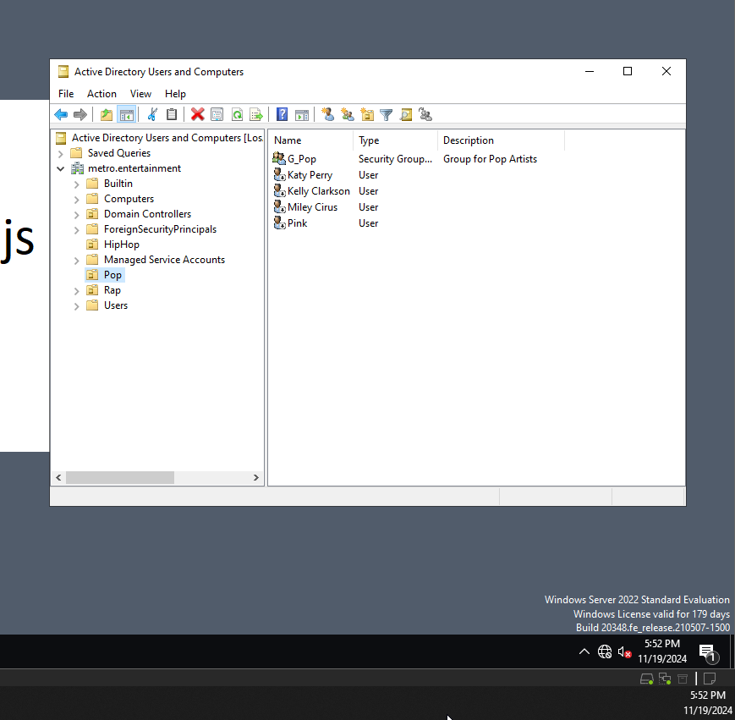  
  Rap Members  
  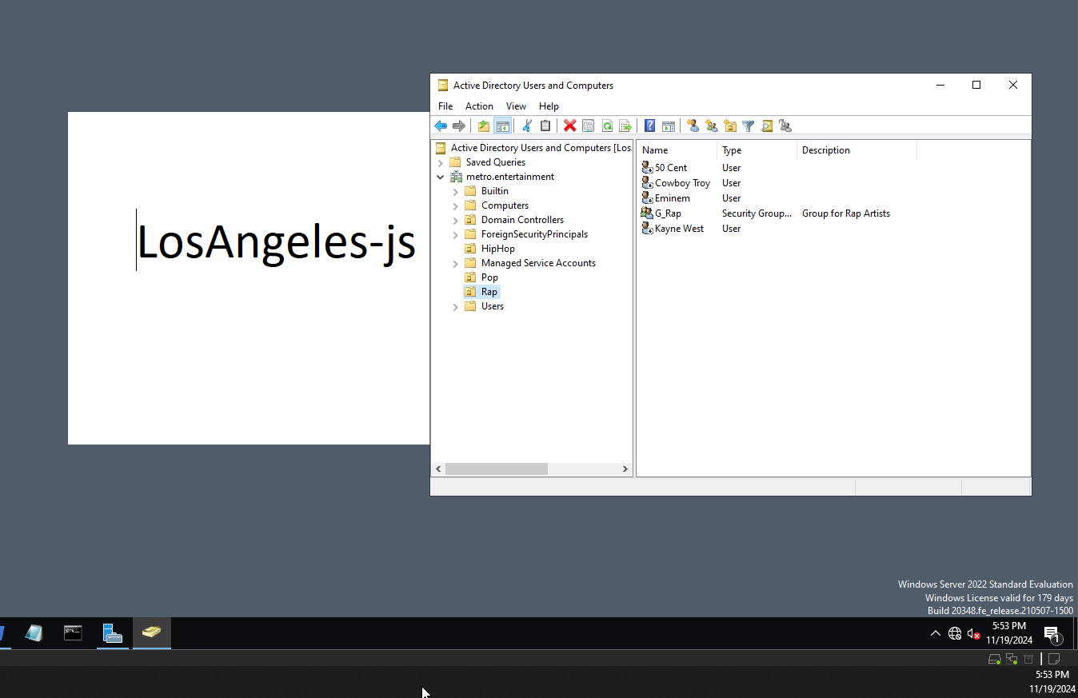
* All twelve users - in their groups and OUS  
  A screenshot of a computer

  Description automatically generated  
  A screenshot of a computer

  Description automatically generated

* Screenshot of the CSV file and the command being run

